|  |
| --- |
| **CME 2203 Lab 4 Pre-lab**  **Due Date:** 4 November 2019, 12:30  **Name:**  **Student Number:**  **Session- Group:** (e.g. Monday 13:00, 42)  **Subject:** Diodes |

☞ Please read this document from start to finish carefully before starting your work.

☞ Prepare as a **PDF** including screenshot and simulation graph.

☞ Prelab must be prepared INDIVIDUALLY and uploaded to Google Classroom course page.

Draw the following circuit on LTSpice Schematics and save to a folder of your choice. Note that the screenshot we want is more than just the circuit; we want simulation graphs as well.

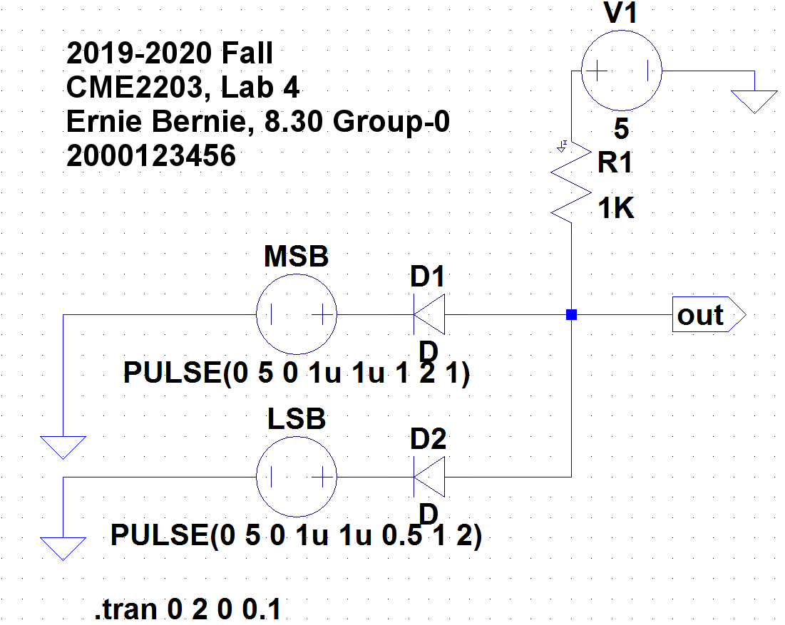

1. For your screenshot, top of the window should contain the graph plot panes, and the bottom of the window should contain:
   1. The circuit diagram
   2. The text label
2. Create the circuit schematic shown above. Note that we use **square pulses** to create all combinations of MSB and LSB. You can see the parameter values below the logic input voltage sources MSB and LSB. You can make both MSB and LSB provide **pulses for 4 cycles**.
3. Adjust the component values as follows:
   1. For V1 we can just assign a DC value of +5V.
   2. We want MSB and LSB to act as a switch we open and close periodically, so we want it to produce a square wave voltage pattern.
   3. To achieve this, right click on LSB and click Advanced. Select PULSE. Enter the parameters as follows (letter **u** works for microsecond):
      1. Vinitial(V) : 0
      2. Von(V) : 5
      3. Tdelay(s) : 0
      4. Trise(µs) : 1u
      5. Tfall(µs) : 1u
      6. Ton(s) : 0.5
      7. Tperiod(s) : 1
      8. Ncycles : 2

This setting creates a square wave with a period of 1s, and because it’s on(+5V) at only 0.5s, so its DUTY CYCLE is 50%. It lasts for 2 cycles, so for (cycle no)x(period T) = 2x1 = 2 seconds.

* 1. Now, right click on MSB and click Advanced. Select PULSE. Enter the parameters as follows (letter **u** works for microsecond):
     1. Vinitial(V) : 0
     2. Von(V) : 5
     3. Tdelay(s) : 0
     4. Trise(µs) : 1u
     5. Tfall(µs) : 1u
     6. Ton(s) : 1
     7. Tperiod(s) : 2
     8. Ncycles : 1

This setting creates a square wave with a period of 2s. It lasts for only one cycle, so 1x2 = 2 s.

1. Now, we are ready to run the simulation! Click on the running man  and edit the simulation command (Remember, you can also change this command later by going to Simulate\Edit Simulation Command):
   1. Under the Transient tab, select the following parameters:
      1. Stop Time : 2
      2. Time to Start Saving Data : 0
      3. Maximum Time Step : 0.1 and click OK.

This means you run the simulation from 0 to 2s. with time intervals of 100ms. Click the running man again. You should see an empty graph on top of the window now. Let’s fill it with graphs!

* 1. Now, move the cursor to the graph, right click and select Add Plot Pane. Now you should have a total of three voltage plot panes.
  2. Click on the top graph pane, then click the red probe appearing on the circuit to the wire connecting to positive side of LSB, to the left of diode. This is our first logic input.
  3. Click on the middle graph pane, then click the red probe appearing on the circuit to the wire connecting to positive side of MSB, to the left of diode. This is our second logic input.
  4. Click on the bottom graph pane, then click on the wire that connects to **Out** port. This is the logic output.

So your final screenshot should be like this (Out voltage not shown)

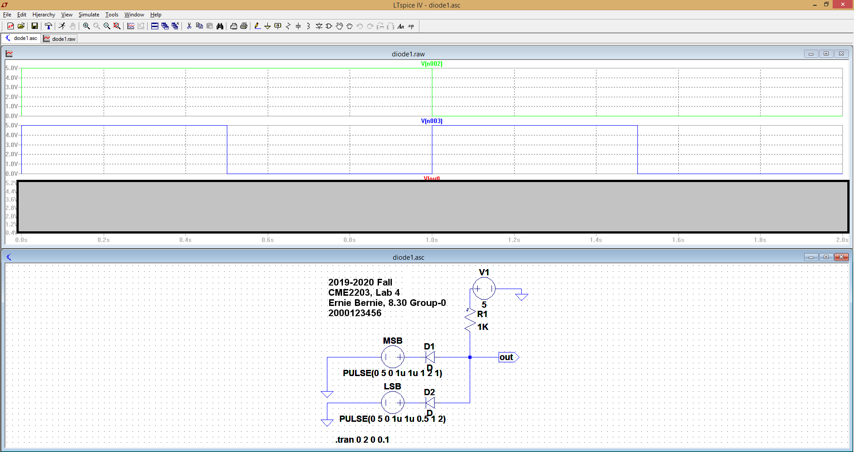

Congratulations! You are all set! Now have some rest.

**For your own learning and preparing lab experiment:**

-Try to understand how this circuit works.

-What are some possible disadvantages of using diodes as gates?